Doctor Appointment Booking System

Statement about the Problem:
The healthcare sector is rapidly evolving, with an increasing demand for a streamlined and efficient appointment scheduling experience. This project aims to address the challenges faced by both patients and healthcare providers in managing and accessing appointment-related information. The primary objective is to design and develop a comprehensive Doctor Appointment Booking System that includes separate modules/interfaces for patients, doctors, and administrators.
The system will enable patients to book, reschedule, or cancel appointments, while doctors can manage their schedules and availability. Additionally, the platform will provide real-time notifications, secure patient-doctor communication, and integration with electronic health records. The development of this system will ensure a user-friendly, secure, and efficient healthcare booking process. The successful implementation of this project will improve patient access to healthcare, optimize doctor schedules, and enhance overall healthcare service delivery.

Why this particular topic is chosen?
The choice of creating a Doctor Appointment Booking System is driven by several compelling reasons and considerations:
• Improving Healthcare Access: Traditional appointment booking methods are often time-consuming and inefficient. This system enhances accessibility by allowing patients to book appointments online easily.
• Enhancing Patient Experience: Convenience and timely access to healthcare services are crucial. This application streamlines appointment scheduling, reminders, and doctor-patient communication, leading to improved patient satisfaction.
• Efficient Doctor & Schedule Management: Doctors can manage their availability, appointments, and patient history more efficiently, reducing scheduling conflicts and optimizing their workflow.
• Data Management & Security: Healthcare generates vast amounts of sensitive data daily. This system will securely store and manage patient records, ensuring compliance with privacy regulations and easy data access for authorized users.
• Remote & Emergency Access: Patients can book or cancel appointments remotely, ensuring flexibility. Additionally, emergency slots can be managed for urgent medical needs.
By implementing this system, healthcare services become more streamlined, patient-centered, and accessible to a wider population.

Objective of the Doctor Appointment Booking System:
The main objective of this project is to develop a feature-rich online appointment booking system for healthcare services. The platform will offer a range of functionalities to streamline appointment scheduling, patient management, and doctor availability tracking.
- Appointment Scheduling & Management: To provide an easy-to-use system for patients to book, reschedule, or cancel appointments with healthcare professionals.
- Patient Information Management: To record and manage essential patient details, ensuring accurate and secure data storage.
- Doctor Availability & Scheduling: To allow doctors to set their availability, manage appointments, and avoid scheduling conflicts
- Specialization & Department Categorization: To organize doctors based on their specializations, making it easier for patients to find the right doctor
- Admin Panel: To manage appointments, patient records, doctors, and system configurations efficiently.

Scope of the Doctor Appointment Booking System Project:
The scope of this project includes the following key features:
- User Registration & Profile Management: Patients and doctors can create and manage their profiles securely.
- Doctor Listings & Specialization Details: Patients can browse through doctors based on specialty and availability.
- Appointment Booking System: Patients can schedule, reschedule, or cancel appointments.
- Filter Options: Users can search doctors based on specialization, fees.
- Secure Payment Options: Patients can pay for consultations securely via multiple payment methods.
- Admin Panel for Management: Admins can manage users, doctors, schedules, and system settings.

Methodology:
The "Waterfall methodology" will be used to complete this doctor appointment booking system. The Waterfall methodology is a straightforward approach that involves five phases:
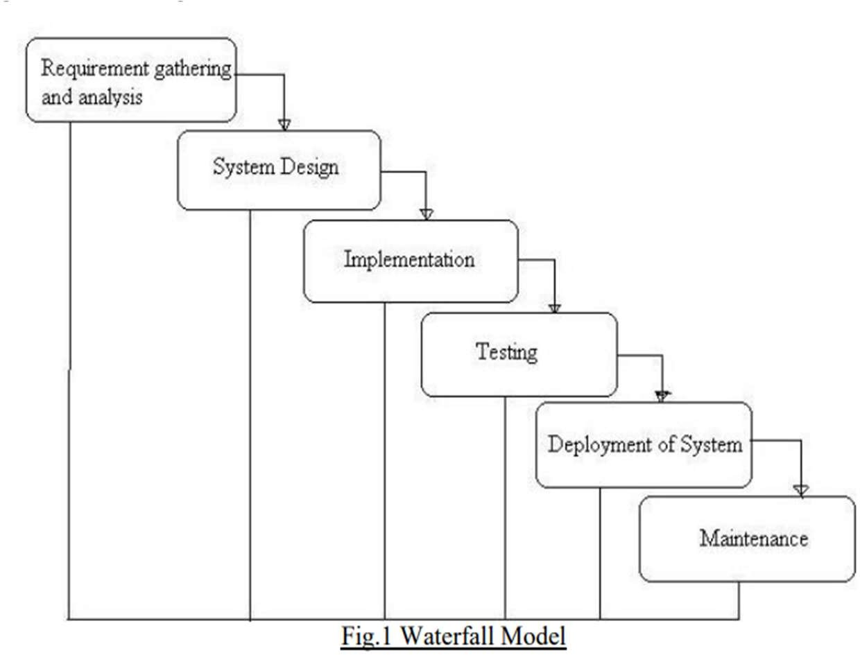

ER DIAGRAM:-

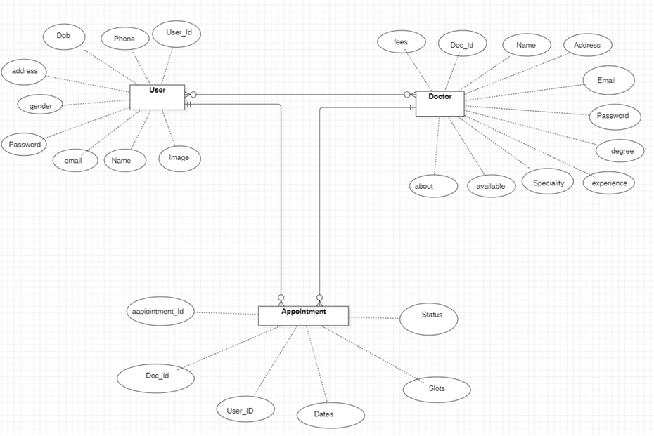

Use case :

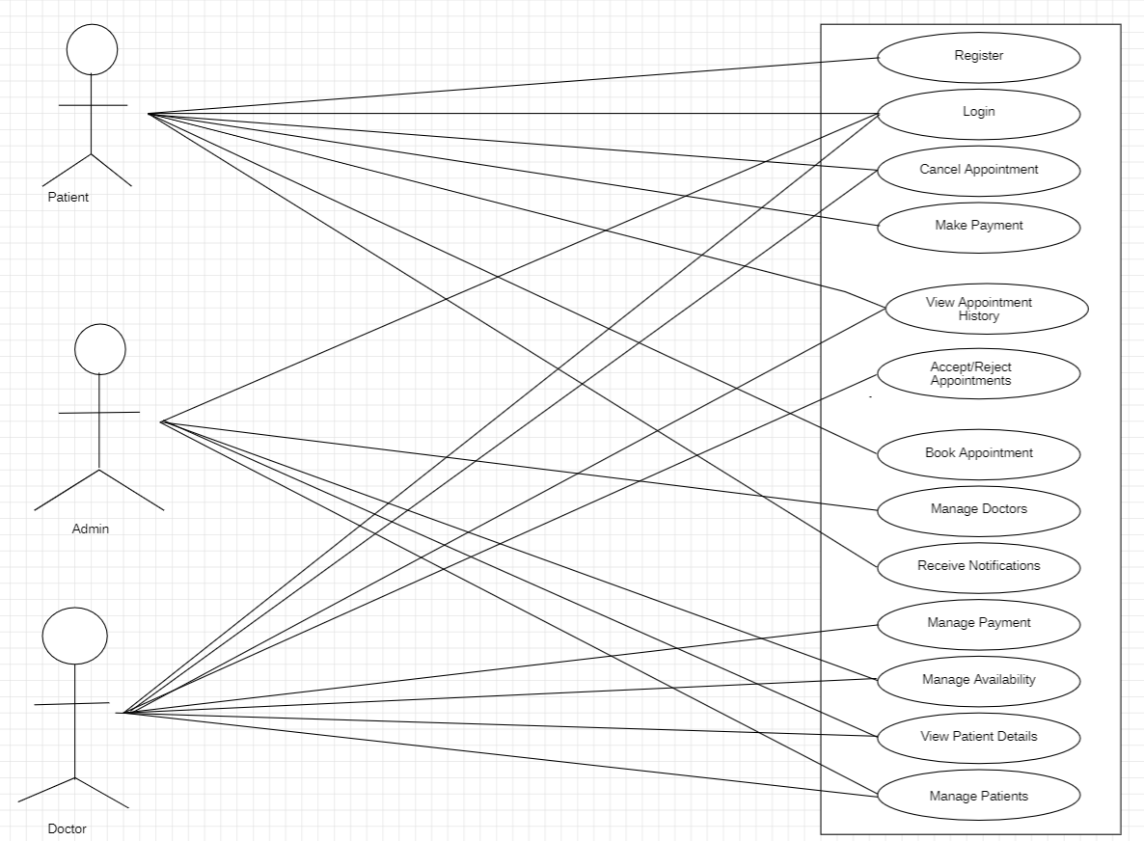

DFD

0-LEVEL-DFD:

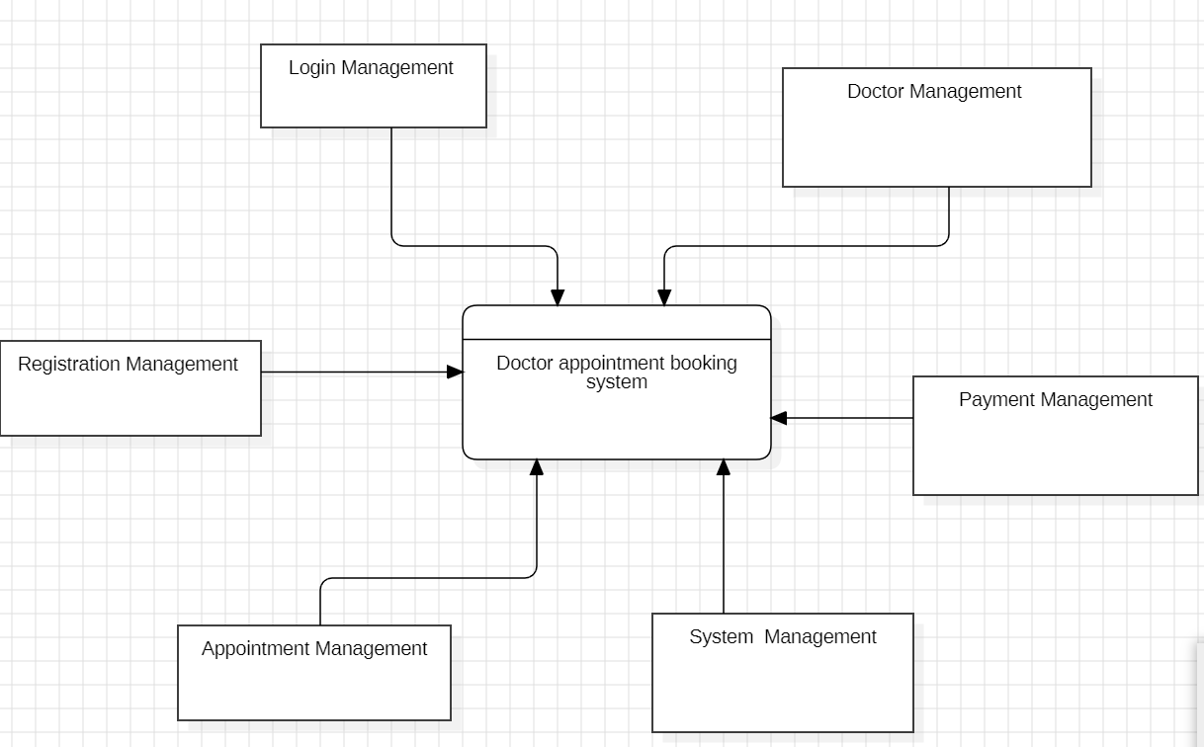

1-LEVEL-DFd:

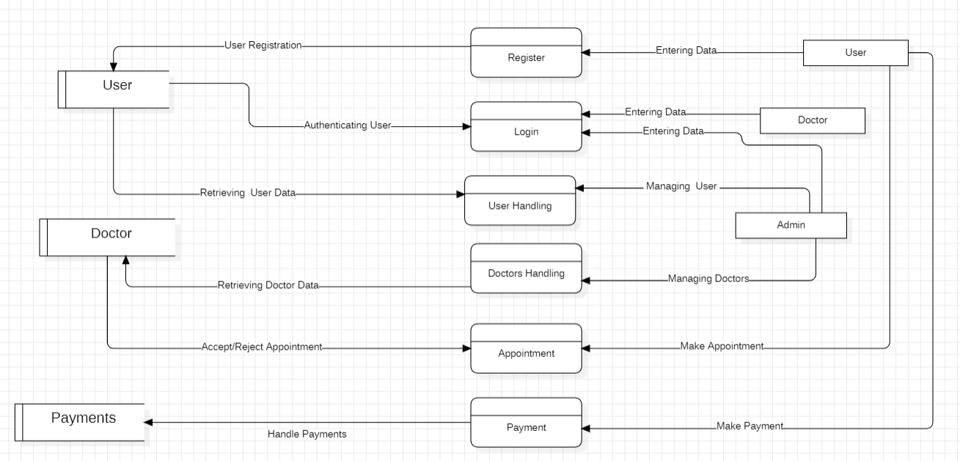

2-lEVEL-DFD:

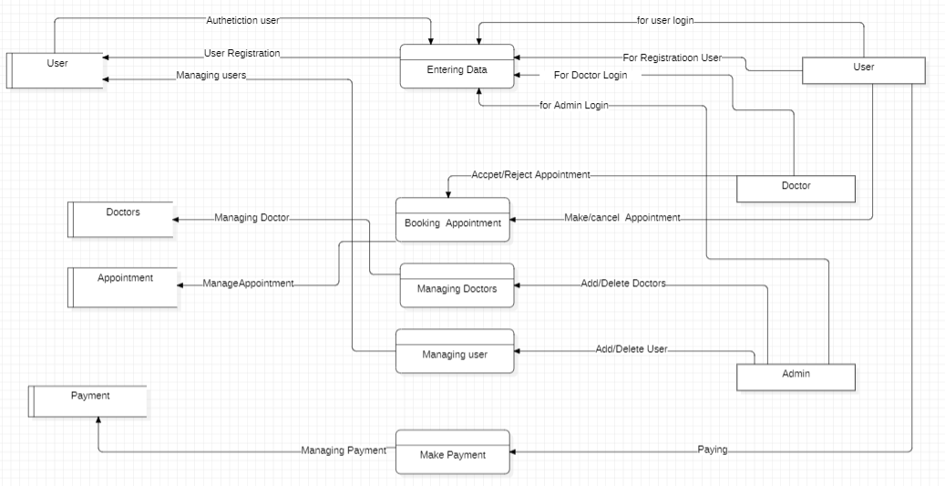

Data Dictionary

Table 1: user
S.no | Field name | Field type | Constraint
1 | _id | String | Primary key
2 | name | String | Not Null
3 | email | String | Not Null, Unique
4 | password | String | Not Null
5 | phone | String | Unique
6 | address | String | Default: {line1: '', line2: ''}
7 | gender | String | Default: "Not Selected"
8 | dob | String | Default: "Not Selected"

Table2: Doctor
S.no | Field name | Field type | Constraint
1 | _id | ObjectId | Primary Key
2 | name | String | Not Null
3 | email | String | Not Null, Unique
4 | password | String | Not Null
5 | image | String | Not Null
6 | speciality | String | Not Null
7 | degree | String | Not Null
8 | experience | String | Not Null
9 | about | String | Not Null
10 | available | Boolean | Not Null
11 | fees | Number | Not Null
12 | address | Object | Not Null
13 | date | Number | Not Null
14 | slots_booked | Object | Default: {}

Table 3: Appointment
S.no | Field name | Field type | Constraint
1 | userId | String | Primary key
2 | docId | String | Not Null
3 | slotDate | String | Not Null
4 | slotTime | Object | Not Null
5 | docData | Object | Not Null
6 | userData | Object | Not Null
7 | amount | Number | Not Null
8 | date | Number | Not Null
9 | cancelled | Boolean | Default: false
10 | payment | Boolean | Default: false
11 | isCompleted | Boolean | Default: false

Hardware & Software to be used: Hardware:
  - Processor: Intel Core i3
  - RAM: 4GB
  - Hard disk: 1 TB (minimum 80GB)

Software:
  - Operating System: Windows 7, 10
  - Front-end: HTML, CSS, JavaScript, React
  - Server-side: Node.js, Express.js
  - Database: MongoDB
  - IDE: Visual Studio Code
  - Project type: Web application

Testing Technologies used:
The project involves two main types of testing:
  - Unit Testing: Focuses on verifying the correctness of small, isolated pieces of code within the backend and frontend. It helps catch and rectify errors in the early stages of development.
  - Manual Testing: Essential for evaluating user interfaces and overall user experiences. It assesses aspects that may be challenging to automate, such as visual design, usability, and subjective user interfaces.
  - UAT(User Acceptance Testing): Execute User Acceptance Testing (UAT) to confirm that the final product meets all specified requirements and is ready for deployment.

Contribution of the Doctor Appointment Booking System Project:

A doctor appointment booking system can bring significant benefits to the healthcare industry. It streamlines the appointment scheduling process, reducing paperwork and minimizing administrative burdens on medical staff. Patients can easily browse available slots, book appointments leading to an improved overall experience. The system enables remote access for patients, ensuring convenience and continuity of care. Additionally, developing this system allows for the implementation of robust security measures to protect patient data and ensure compliance with healthcare regulations.

